Hardware

The hardware requirements for a rover for the University Rover Challenge (URC) are as follows:

* **Rover chassis:** The rover chassis is the base of the rover and provides the structure and stability. It must be able to support the weight of the rover and its payload, and it must be able to withstand the rigors of the Martian environment.
* **Power system:** The power system provides the power for the rover's motors, sensors, and electronics. It must be able to provide enough power to operate the rover for the duration of the competition.
* **Motors:** The motors are responsible for moving the rover. They must be able to provide enough torque to move the rover over rough terrain.
* **Transmission:** The transmission transfers the power from the motors to the wheels. It must be able to handle the torque from the motors and it must be able to shift gears to allow the rover to move at different speeds.
* **Wheels:** The wheels are the rover's way of interacting with the Martian surface. They must be able to provide traction and they must be able to withstand the rigors of the Martian environment.
* **Sensors:** The sensors are used to gather information about the environment around the rover. They must be able to detect obstacles, measure distances, and identify objects.
* **Computer:** The computer is responsible for controlling the rover's systems. It must be powerful enough to run the rover's software and it must be able to withstand the harsh environment of Mars.
* **Communication system:** The communication system allows the rover to communicate with the ground station. It must be able to transmit and receive data over long distances.

Motors

There are several factors and specific details to consider when choosing motors for the University Rover Challenge (URC). These include:

* **Torque:** The torque is the amount of force that the motor can apply to the wheels. The rover needs to be able to move over rough terrain, so the motors need to have enough torque to overcome the resistance of the ground.
* **Speed:** The speed is the rate at which the motor can turn the wheels. The rover needs to be able to move at different speeds, so the motors need to have a wide range of speeds.
* **Weight:** The weight of the motors is an important consideration, as the rover needs to be able to carry the weight of the motors and its payload.
* **Power consumption:** The power consumption of the motors is also an important consideration, as the rover needs to have enough power to operate the motors for the duration of the competition.
* **Durability:** The motors need to be durable enough to withstand the rigors of the Martian environment.
* **Cost:** The cost of the motors is also an important consideration, as the team needs to stay within their budget.

In addition to these factors, the team also needs to consider the specific requirements of the URC. The URC has specific requirements for the size, weight, and power consumption of the motors.

Here are some of the popular choices of motors for various tasks of the University Rover Challenge (URC):

* **DC motors:** DC motors are the most common type of motor used in rovers. They are relatively inexpensive and easy to find. However, they are not as efficient as other types of motors.

[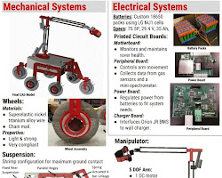Opens in a new window[](https://sansantonio.com/AnthonyWagner/URC)sansantonio.com](https://sansantonio.com/AnthonyWagner/URC)

DC motors for the University Rover Challenge (URC)

* **Brushless DC motors:** Brushless DC motors are more efficient than DC motors. They are also more reliable and they can operate at higher speeds. However, they are more expensive and they require more complex control electronics.

[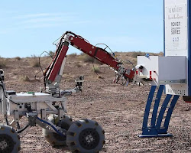Opens in a new window[](https://engineering.usu.edu/mae/students/senior-projects/fall2018-spring2019/university-rover-manipulation)engineering.usu.edu](https://engineering.usu.edu/mae/students/senior-projects/fall2018-spring2019/university-rover-manipulation)

Brushless DC motors for the University Rover Challenge (URC)

* **Stepper motors:** Stepper motors are used for precise positioning. They are not as powerful as other types of motors, but they can be used to move the rover in a very controlled way.

[Opens in a new window[](https://sansantonio.com/AnthonyWagner/URC)sansantonio.com](https://sansantonio.com/AnthonyWagner/URC)

Stepper motors for the University Rover Challenge (URC)

* **Servo motors:** Servo motors are used for applications where the position of the motor shaft must be controlled accurately. They are not as powerful as other types of motors, but they can be used to control the rover's wheels or other actuators.

[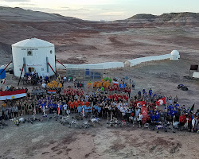Opens in a new window[](https://en.wikipedia.org/wiki/University_Rover_Challenge)en.wikipedia.org](https://en.wikipedia.org/wiki/University_Rover_Challenge)

Servo motors for the University Rover Challenge (URC)

Here are some of the most popular motors used in URC rovers:

* **NeveRest 435 Continuous Duty Motor:** This motor is a popular choice for URC rovers because it is powerful, efficient, and durable. It has a torque of 1500 in-lbs and a speed of 180 RPM.

[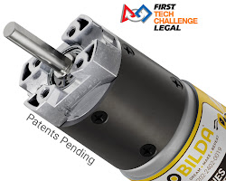](https://www.gobilda.com/yellow-jacket-planetary-gear-motors/)

NeveRest 435 Continuous Duty Motor

* **Maxon EC45 Flat Motor:** This motor is another popular choice for URC rovers because it is compact and lightweight. It has a torque of 1000 in-lbs and a speed of 200 RPM.

[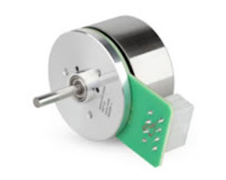](https://uk.rs-online.com/web/p/dc-motors/1817546)

Maxon EC45 Flat Motor

* **Hiwin 500W Brushless DC Motor:** This motor is a good choice for URC rovers that need a lot of power. It has a torque of 2000 in-lbs and a speed of 120 RPM.

[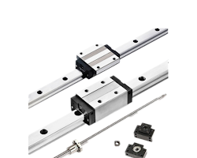](https://www.dec-motor.com/good-quality-linear-stepper-motor-hiwin-linear-motion-guide-rail-and-slider-carriage-hg15-hg20-hg25-hg30-hg35-hg45-bobet-10-product/)

Hiwin 500W Brushless DC Motor

* **Talon SRX Motor Controller:** This motor controller is a popular choice for URC rovers because it is powerful, easy to use, and affordable. It can control up to 6 motors and it has a built-in encoder.

[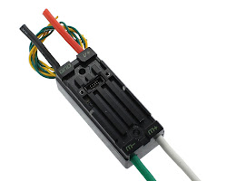](https://www.andymark.com/products/talon-srx-speed-controller)

Talon SRX Motor Controller

Here are some specific details to consider when choosing motors for the URC:

* The type of motor: There are two main types of motors that are commonly used in rovers: DC motors and brushless DC motors. DC motors are less expensive, but they are not as efficient as brushless DC motors. Brushless DC motors are more expensive, but they are more efficient and they can operate at higher speeds.
* The voltage: The voltage of the motor must be compatible with the power system of the rover.
* The current: The current that the motor draws must be within the limits of the power system of the rover.
* The mounting: The motor must be able to be mounted to the rover chassis in a way that allows it to move freely.
* The durability: The motor must be able to withstand the rigors of the Martian environment.

There are many different software drive systems that can be used for the motors in a rover. Some of the most popular ones include:

* **Proportional-integral-derivative (PID) control:** PID control is a widely used control algorithm that can be used to control a wide variety of systems, including motors. PID control works by adjusting the output of the motor in proportion to the error between the desired and actual positions of the motor.

[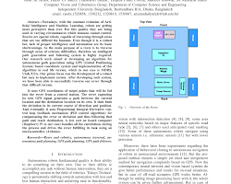Opens in a new window[](https://www.researchgate.net/publication/326795727_Autonomous_Rover_Navigation_Using_GPS_Based_Path_Planning)www.researchgate.net](https://www.researchgate.net/publication/326795727_Autonomous_Rover_Navigation_Using_GPS_Based_Path_Planning)

Proportional-integral-derivative (PID) control for the University Rover Challenge (URC)

* **Fuzzy logic control:** Fuzzy logic control is a type of control that uses fuzzy logic to make decisions. Fuzzy logic is a way of representing uncertainty and vagueness, which can be useful in controlling systems that are difficult to model mathematically.

[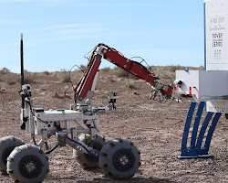Opens in a new window[](https://www.huskyrobotics.me/)www.huskyrobotics.me](https://www.huskyrobotics.me/)

Fuzzy logic control for the University Rover Challenge (URC)

* **Neural network control:** Neural network control is a type of control that uses neural networks to make decisions. Neural networks are a type of artificial intelligence that can learn from data. This can be useful in controlling systems that are difficult to model mathematically or that are constantly changing.

[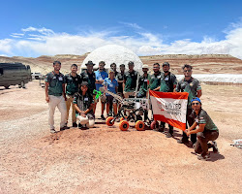Opens in a new window[](https://www.thedailystar.net/tech-startup/news/uiu-places-1st-among-asian-teams-university-rover-challenge-2023-3340006)www.thedailystar.net](https://www.thedailystar.net/tech-startup/news/uiu-places-1st-among-asian-teams-university-rover-challenge-2023-3340006)

Neural network control for the University Rover Challenge (URC)

* **Genetic algorithm control:** Genetic algorithm control is a type of control that uses genetic algorithms to make decisions. Genetic algorithms are a type of evolutionary algorithm that can be used to find solutions to optimization problems.

[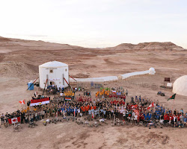Opens in a new window[](https://engineering.usu.edu/mae/students/senior-projects/fall2018-spring2019/university-rover-competition)engineering.usu.edu](https://engineering.usu.edu/mae/students/senior-projects/fall2018-spring2019/university-rover-competition)

Genetic algorithm control for the University Rover Cha

• **Open-loop control:** Open-loop control is a simpler control algorithm that does not require feedback from the motor. Open-loop control works by simply setting the output of the motor driver to a constant value.

[Opens in a new window[](https://engineering.usu.edu/mae/students/senior-projects/fall2018-spring2019/university-rover-manipulation)engineering.usu.edu](https://engineering.usu.edu/mae/students/senior-projects/fall2018-spring2019/university-rover-manipulation)

Open-loop control for the University Rover Challenge (URC)

• **Closed-loop control:** Closed-loop control is a more complex control algorithm that uses feedback from the motor to adjust the output of the motor driver. Closed-loop control can be more precise than open-loop control, but it is also more complex to implement.

[Opens in a new window[](https://en.wikipedia.org/wiki/University_Rover_Challenge)en.wikipedia.org](https://en.wikipedia.org/wiki/University_Rover_Challenge)

Closed-loop control for the University Rover Challe

To build a good drive system for the motors in the rover from the software side, you will need to:

1. **Choose the right motor driver:** The motor driver is the electronic circuit that controls the motors. There are many different motor drivers available, each with its own advantages and disadvantages. The team should choose a motor driver that is appropriate for the specific needs of their rover.
2. **Write the control software:** The control software is the program that controls the motor driver. The software will need to be able to read the input from the joystick and generate the output signals that control the motors.
3. **Test the drive system:** The drive system should be tested to make sure that it is working properly. The team should test the drive system in different scenarios, such as moving the rover forward, backward, and turning

Here are some of the popular drive systems and driver software used for the motors in the University Rover Challenge (URC):

* **Victor SPX:** The Victor SPX is a popular motor driver for the URC. It is a brushless DC motor driver that is capable of driving up to 60 amps. It is also relatively inexpensive and easy to use.

[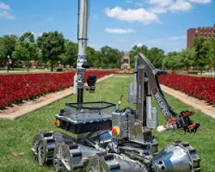Opens in a new window[](https://blogs.ou.edu/ame/category/uncategorized/)blogs.ou.edu](https://blogs.ou.edu/ame/category/uncategorized/)

Victor SPX for the University Rover Challenge (URC)

* **Talon SRX:** The Talon SRX is another popular motor driver for the URC. It is also a brushless DC motor driver, but it is capable of driving up to 120 amps. It is more expensive than the Victor SPX, but it offers more features and capabilities.

[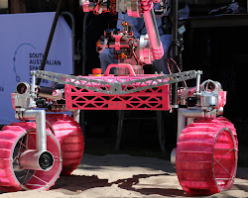Opens in a new window[](https://www.novarover.space/rovers)www.novarover.space](https://www.novarover.space/rovers)

Talon SRX for the University Rover Challenge (URC)

* **Spark MAX:** The Spark MAX is a newer motor driver that is becoming increasingly popular in the URC. It is a brushless DC motor driver that is capable of driving up to 150 amps. It is also very versatile and can be used with a variety of different sensors and controllers.

[Opens in a new window[](https://engineering.usu.edu/mae/students/senior-projects/fall2018-spring2019/university-rover-manipulation)engineering.usu.edu](https://engineering.usu.edu/mae/students/senior-projects/fall2018-spring2019/university-rover-manipulation)

Spark MAX for the University Rover Challenge (URC)

* **OpenCR:** OpenCR is an open-source hardware and software platform for robotics. It is a popular choice for the URC because it is affordable, flexible, and easy to use.

[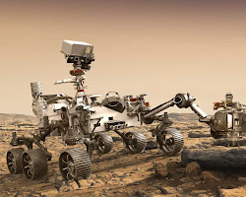Opens in a new window[](https://engineering.usu.edu/mae/students/senior-projects/fall2018-spring2019/university-rover-navigation)engineering.usu.edu](https://engineering.usu.edu/mae/students/senior-projects/fall2018-spring2019/university-rover-navigation)

OpenCR for the University Rover Challeng

Sensors

There are a variety of sensors that can be used for the various tasks of the University Rover Challenge (URC). The specific sensors that are required will depend on the specific tasks that the rover is being designed to perform.

Some of the most common sensors used in URC rovers include:

* **Odometry:** Odometry is a system for measuring the distance traveled by a vehicle. It is typically used to track the rover's position and orientation.
* **Inertial measurement unit (IMU):** An IMU is a sensor that measures the orientation and angular velocity of a vehicle. It is used to track the rover's orientation and to help with navigation. They can be used for navigation and obstacle avoidance.
* **Cameras:** Cameras are used to see the environment around the rover. They can be used for navigation, object detection, and terrain analysis.
* **Ultrasonic sensors:** Ultrasonic sensors use sound waves to measure the distance to objects. They can be used for obstacle detection and range finding.
* **Touch sensors:** Touch sensors are used to detect when the rover has come into contact with an object. They can be used for obstacle avoidance and collision detection.
* **Magnetic sensors:** Magnetic sensors are used to measure the magnetic field around the rover. They can be used for navigation and obstacle detection.
* **Rangefinders:** Rangefinders are used to measure the distance between the rover and objects in the environment. They can be used for navigation, obstacle avoidance, and object identification..
* **GPS:** GPS is used to determine the position of the rover. It can be used for navigation and for returning to a known location.
* **Magnetometers:** Magnetometers are used to measure the magnetic field of the Earth. They can be used for navigation and for determining the orientation of the rover.
* **Touch sensors:** Touch sensors are used to detect when the rover has come into contact with an object. They can be used for obstacle avoidance and for object identification.
* **Sonar:** Sonar is used to measure the distance between the rover and objects in the environment by emitting sound waves and measuring the time it takes for the waves to return. It can be used for navigation and obstacle avoidance.
* **LIDAR:** LIDAR (Light Detection and Ranging) is a type of laser scanner that is used to measure the distance between the rover and objects in the environment by emitting laser pulses and measuring the time it takes for the pulses to return. It can be used for navigation, terrain mapping, object iderntification, obstacle avoidance, and object identification.

The team should carefully consider the specific tasks that the rover is being designed to perform when choosing the sensors. By choosing the right sensors, the team can increase the chances of their rover being successful in the competition.

In addition to the sensors listed above, there are a variety of other sensors that can be used in URC rovers. The specific sensors that are used will depend on the specific needs of the team and the budget.

Here are some additional considerations for choosing sensors for the URC:

* The cost of the sensor: The cost of the sensor is an important factor, as the team needs to stay within their budget.
* The weight of the sensor: The weight of the sensor is important, as the rover needs to be as lightweight as possible.
* The power consumption of the sensor: The power consumption of the sensor is important, as the rover needs to be able to operate for a long time.
* The durability of the sensor: The sensor must be able to withstand the rigors of the Martian environment.
* The availability of the sensor: The sensor must be available for purchase or fabrication.

The sensor requirements and specifications for the rover in the science mission will depend on the specific science experiments that the rover is being asked to perform. However, some of the most common sensors used in science missions include:

* **Cameras:** Cameras can be used to capture images of the environment around the rover. These images can be used to identify objects, study the geology of the Martian surface, and search for signs of life. The cameras must be able to capture images of the environment around the rover at a resolution of at least 1280x720 pixels. They must also be able to capture images at a frame rate of at least 30 frames per second.
* **Spectrometers:** Spectrometers can be used to measure the wavelength of light emitted or reflected by an object. This information can be used to identify the chemical composition of the object.
* **Magnetometers:** Magnetometers can be used to measure the magnetic field. This information can be used to study the Martian magnetic field and the history of the planet.
* **Gas chromatographs:** Gas chromatographs can be used to identify gases in the Martian atmosphere. This information can be used to study the composition of the atmosphere and the history of the planet.
* **Mass spectrometers:** Mass spectrometers can be used to identify the elements and molecules in a sample. This information can be used to study the composition of the Martian surface and the history of the planet.
* **Temperature sensors:** The temperature sensors must be able to measure the temperature of the environment around the rover. This can be used to identify the presence of water or other liquid environments that could support life

Here are some of the sensor requirements and specifications for the rover in the navigation mission:

* **Range sensors:** The range sensors must be able to measure the distance between the rover and an object at a range of at least 10 meters. They must also be able to measure the distance to multiple objects simultaneously.
* **Cameras:** The cameras must be able to capture images of the environment around the rover at a resolution of at least 640x480 pixels. They must also be able to capture images at a frame rate of at least 30 frames per second.
* **IMUs:** The IMUs must be able to measure the orientation and angular velocity of the rover with an accuracy of at least 0.1 degrees.
* **GPS:** The GPS must be able to determine the location of the rover with an accuracy of at least 10 meters.
* **Magnetometers:** The magnetometers must be able to measure the magnetic field with an accuracy of at least 0.1 microtesla.

In addition to these sensors, the rover may also need to include other sensors, such as:

* **Sonars**: The sonars must be able to measure the distance to an object at a range of at least 10 meters. The sensors must also be able to measure the distance to an object with an accuracy of at least 10 centimeters. nar can be used to measure the distance to an object by emitting a sound wave and measuring the time it takes for the wave to return. It can be used for obstacle avoidance and navigation.
* **LIDAR**: LIDAR (Light Detection and Ranging) is a sensor that uses a laser to measure the distance to an object. It can be used for obstacle avoidance, navigation, and object detection.
* **Thermal cameras:** Thermal cameras can be used to detect objects that are not visible to the naked eye, such as heat signatures. They can be used for navigation and object detection.

The sensor requirements and specifications for the rover in the extreme delivery mission are similar to those for the navigation mission, but there are some additional considerations.

* **Range sensors:** The range sensors must be able to measure the distance between the rover and an object at a range of at least 20 meters. They must also be able to measure the distance to an object with an accuracy of at least 20 centimeters.
* **Cameras:** The cameras must be able to capture images of the environment around the rover at a resolution of at least 1280x720 pixels. They must also be able to capture images at a frame rate of at least 60 frames per second.
* **IMUs:** The IMUs must be able to measure the orientation and angular velocity of the rover with an accuracy of at least 0.05 degrees and 0.005 rad/s, respectively.
* **GPS:** The GPS must be able to determine the location of the rover with an accuracy of at least 5 meters.
* **Magnetometers:** The magnetometers must be able to measure the magnetic field with an accuracy of at least 0.05 microtesla.
* **LiDAR:** The LiDAR must be able to measure the distance between the rover and an object at a range of at least 100 meters. It must also be able to measure the distance to an object with an accuracy of at least 10 centimeters.
* **Sonar:** The sonar must be able to measure the distance to an object by emitting a sound wave and measuring the time it takes for the wave to return. It must be able to measure the distance to an object with an accuracy of at least 10 centimeters.
* **Additional sensors:** The rover may also need additional sensors, such as a thermal camera, to help it navigate in difficult terrain or to detect hazardous objects.

Here are some of the sensor requirements and specifications for the robotic arm in the extreme delivery mission:

* **Range sensors:** The range sensors must be able to measure the distance between the robotic arm and an object at a range of at least 1 meter. They must also be able to measure the distance to an object with an accuracy of at least 1 centimeter.
* **Cameras:** The cameras must be able to capture images of the environment around the robotic arm at a resolution of at least 640x480 pixels. They must also be able to capture images at a frame rate of at least 30 frames per second.
* **Force sensors:** The force sensors must be able to measure the force that is being applied to the robotic arm. They must also be able to measure the force with an accuracy of at least 1 Newton.
* **Torque sensors:** The torque sensors must be able to measure the torque that is being applied to the robotic arm. They must also be able to measure the torque with an accuracy of at least 1 Newton-meter.
* **IMUs:** The IMUs must be able to measure the orientation and angular velocity of the robotic arm with an accuracy of at least 0.1 degrees and 0.01 rad/s, respectively.
* **Touch sensors:** The touch sensors must be able to detect contact between the robotic arm and an object.

The specific sensor requirements and specifications will depend on the specific delivery algorithm that is being used. For example, a delivery algorithm that is based on visual serving will require different sensors than a delivery algorithm that is based on force control.

Here are some of the sensor requirements and specifications for the robotic arm in the equipment service mission:

* **Range sensors:** The range sensors must be able to measure the distance between the end effector of the robotic arm and an object at a range of at least 1 meter. They must also be able to measure the distance to an object with an accuracy of at least 1 centimeter.
* **Cameras:** The cameras must be able to capture images of the object that the robotic arm is interacting with. They must also be able to capture images at a frame rate of at least 30 frames per second.
* **Force/torque sensors:** The force/torque sensors must be able to measure the force and torque that the robotic arm is applying to the object. This is important for preventing the robotic arm from damaging the object.
* **IMUs:** The IMUs must be able to measure the orientation and angular velocity of the robotic arm. This is important for controlling the robotic arm and preventing it from colliding with obstacles.

The specific sensor requirements and specifications will depend on the specific tasks that the robotic arm is being asked to perform. For example, a robotic arm that is being asked to pick up a delicate object will need different sensors than a robotic arm that is being asked to move a heavy, rugged object.

The team should carefully consider the specific requirements of the extreme delivery mission when choosing sensors for their robotic arm. By choosing the right sensors, the team can increase the chances of their robotic arm being successful in the mission.

Here are some additional considerations for choosing sensors for the robotic arm:

* The cost: The cost of the sensors is a factor, as the team needs to stay within their budget.
* The weight: The weight of the sensors is important, as the robotic arm needs to be as lightweight as possible.
* The power consumption: The power consumption of the sensors is important, as the robotic arm needs to be able to operate for a long time.
* The reliability: The sensors must be reliable and they must be able to withstand the rigors of the Martian environment.

Here are some of the cameras and their specifications for various tasks of the University Rover Challenge (URC):

* **Navigation:** The cameras used for navigation must have a wide field of view and they must be able to capture images in low-light conditions. The resolution of the images must be at least 640x480 pixels. They must also be able to capture images at a frame rate of at least 30 frames per second.
* **Object detection:** The cameras used for object detection must have a high resolution and they must be able to capture images in high-contrast conditions. The resolution of the images must be at least 1280x720 pixels. They must also be able to capture images at a frame rate of at least 10 frames per second.
* **Science experiments:** The cameras used for science experiments must have a high resolution, high magnifications and they must be able to capture images in a variety of lighting conditions. The resolution of the images must be at least 1920x1080 pixels. They must also be able to capture images at a frame rate of at least 5 frames per second.
* **Robotic arm:** The cameras used for the robotic arm must have a high resolution and they must be able to capture images in close-up. The resolution of the images must be at least 2560x1440 pixels. They must also be able to capture images at a frame rate of at least 20 frames per second.

Here are some additional considerations for choosing cameras for the URC:

* The cost: The cost of the cameras is a factor, as the team needs to stay within their budget.
* The weight: The weight of the cameras is important, as the rover needs to be as lightweight as possible.
* The power consumption: The power consumption of the cameras is important, as the rover needs to be able to operate for a long time.
* The field of view: The field of view of the cameras must be wide enough to capture the entire environment around the rover.
* The resolution: The resolution of the cameras must be high enough to identify objects and features in the environment.
* The frame rate: The frame rate of the cameras must be high enough to capture images smoothly.
* The lens: The lens of the cameras must be able to focus on objects at different distances.

Here are some of the popular choices for camera selection for various tasks of the University Rover Challenge (URC):

* **Color cameras:** Color cameras are the most popular choice for the URC. They are able to capture images in color, which can be helpful for object identification and navigation.

[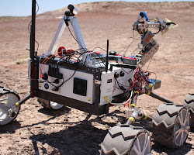Opens in a new window[](http://spex.rit.edu/inroducing-the-spex-rovers-team/)spex.rit.edu](http://spex.rit.edu/inroducing-the-spex-rovers-team/)

Color cameras for the University Rover Challenge (URC)

* **Stereo cameras:** Stereo cameras are a good choice for obstacle avoidance and navigation. They work by capturing two images of the same scene from different angles. The difference between the two images can be used to calculate the depth of the scene, which can be used to avoid obstacles and navigate around them.

[Opens in a new window[](http://spex.rit.edu/inroducing-the-spex-rovers-team/)spex.rit.edu](http://spex.rit.edu/inroducing-the-spex-rovers-team/)

Stereo cameras for the University Rover Challenge (URC)

* **Thermal cameras:** Thermal cameras are a good choice for tasks that require the detection of heat signatures. They can be used to detect objects that are hidden from view or that are difficult to see in low-light conditions.

[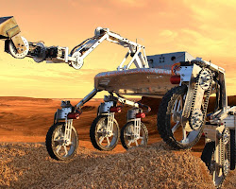Opens in a new window[](https://www.environmentalbiophysics.org/university-rover-challenge/)www.environmentalbiophysics.org](https://www.environmentalbiophysics.org/university-rover-challenge/)

Thermal cameras for the University Rover Challenge (URC)

* **Depth cameras:** Depth cameras are a good choice for tasks that require the measurement of depth. They work by projecting a pattern of light onto the scene and then measuring the time it takes for the light to return. The difference between the time it takes for the light to travel to the object and the time it takes for the light to return can be used to calculate the depth of the object.

[Opens in a new window[](https://www.environmentalbiophysics.org/university-rover-challenge/)www.environmentalbiophysics.org](https://www.environmentalbiophysics.org/university-rover-challenge/)

Depth cameras for the University Rover Challenge (URC)

* **Panoramic cameras:** Panoramic cameras are a good choice for tasks that require a wide field of view. They can be used to capture a wider view of the scene, which can be helpful for navigation and object identification.

[Opens in a new window[](http://spex.rit.edu/inroducing-the-spex-rovers-team/)spex.rit.edu](http://spex.rit.edu/inroducing-the-spex-rovers-team/)

Panoramic cameras for the University Rover Challenge (URC)

Here are some of the popular choices for camera selection for various tasks of the University Rover Challenge (URC):

* **Navigation:** The most popular choice for navigation is a fisheye camera. Fisheye cameras have a wide field of view, which allows the rover to see a wider area around it. They are also relatively inexpensive and easy to use.

[Opens in a new window[](http://spex.rit.edu/inroducing-the-spex-rovers-team/)spex.rit.edu](http://spex.rit.edu/inroducing-the-spex-rovers-team/)

Fisheye camera for the University Rover Challenge (URC)

* **Object detection:** The most popular choice for object detection is a stereo camera. Stereo cameras have two lenses that are mounted side by side. This allows the camera to create a depth map of the environment, which can be used to identify objects.

[Opens in a new window[](http://spex.rit.edu/inroducing-the-spex-rovers-team/)spex.rit.edu](http://spex.rit.edu/inroducing-the-spex-rovers-team/)

Stereo camera for the University Rover Challenge (URC)

* **Science experiments:** The most popular choice for science experiments is a high-resolution camera. High-resolution cameras can capture images with a lot of detail, which can be used to study the Martian surface or to collect data for scientific experiments.

[Opens in a new window[](https://en.wikipedia.org/wiki/University_Rover_Challenge)en.wikipedia.org](https://en.wikipedia.org/wiki/University_Rover_Challenge)

High-resolution camera for the University Rover Challenge (URC)

* **Robotic arm:** The most popular choice for robotic arm manipulation is a pan-tilt-zoom (PTZ) camera. PTZ cameras can be rotated and zoomed, which allows the robotic arm to see the object that it is interacting with from different angles.

[Opens in a new window[](http://spex.rit.edu/inroducing-the-spex-rovers-team/)spex.rit.edu](http://spex.rit.edu/inroducing-the-spex-rovers-team/)

PTZ camera for the University Rover Challenge

Here are some of the popular choices of lidar sensors for various tasks of the University Rover Challenge (URC):

* **Velodyne VLP-16:** The Velodyne VLP-16 is a high-resolution lidar sensor that can measure the distance to an object at a range of up to 100 meters. It has a scanning frequency of 10 Hz and a resolution of 0.1 degree. It is a popular choice for navigation and obstacle avoidance.

[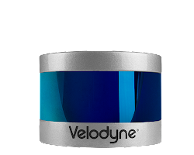Opens in a new window[](https://velodynelidar.com/products/puck/)velodynelidar.com](https://velodynelidar.com/products/puck/)

Velodyne VLP-16 lidar sensor

* **Hokuyo UTM-30LX-EW:** The Hokuyo UTM-30LX-EW is a lower-cost lidar sensor that can measure the distance to an object at a range of up to 30 meters. It has a scanning frequency of 10 Hz and a resolution of 0.3 degree. It is a popular choice for mapping and localization.

[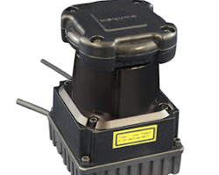Opens in a new window[](https://www.hokuyo-aut.jp/search/single.php?serial=170)www.hokuyo-aut.jp](https://www.hokuyo-aut.jp/search/single.php?serial=170)

Hokuyo UTM-30LX-EW lidar sensor

* **Riegl VZ-16:** The Riegl VZ-16 is a high-performance lidar sensor that can measure the distance to an object at a range of up to 200 meters. It has a scanning frequency of 20 Hz and a resolution of 0.01 degree. It is a popular choice for scientific applications.

[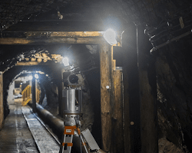Opens in a new window[](https://www.researchgate.net/figure/RIEGL-VZ-400i-Terrestrial-Laser-Scanner-in-the-adit_fig2_363106562)www.researchgate.net](https://www.researchgate.net/figure/RIEGL-VZ-400i-Terrestrial-Laser-Scanner-in-the-adit_fig2_363106562)

Riegl VZ-16 lidar sensor

* **Riegl LMS-151:** The Riegl LMS-151 is a high-performance lidar sensor that can be used for mapping and 3D reconstruction. It has a range of up to 150 meters and a resolution of 1000 points per scan.
* [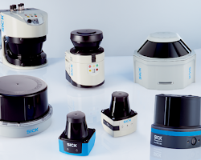Opens in a new window[](https://www.sick.com/jp/en/lidar-sensors/c/g575802)www.sick.com](https://www.sick.com/jp/en/lidar-sensors/c/g575802)

Riegl LMS-151 lidar sensor

* **LidarLite V3:** The LidarLite V3 is a low-cost lidar sensor that can be used for obstacle avoidance and mapping. It has a range of up to 10 meters and a resolution of 10 points per scan.

[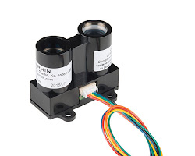Opens in a new window[](https://www.digikey.in/en/products/detail/sparkfun-electronics/SEN-14032/6204382)www.digikey.in](https://www.digikey.in/en/products/detail/sparkfun-electronics/SEN-14032/6204382)

LidarLite V3 lidar sensor

• **Leica Geosystems LDS-150:** The Leica Geosystems LDS-150 is a high-accuracy lidar sensor that can measure the distance to an object at a range of up to 150 meters. It has a resolution of 120 beams and a scanning frequency of 10 Hz. It is a popular choice for surveying and engineering applications.

[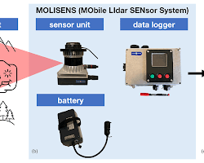Opens in a new window[](https://gi.copernicus.org/articles/11/247/2022/)gi.copernicus.org](https://gi.copernicus.org/articles/11/247/2022/)

Leica Geosystems LDS-150 lidar sensor

Here are some of the popular choices of IMU sensors for various tasks of the University Rover Challenge (URC):

* **Inertial Measurement Unit (IMU):** IMUs are used to measure the orientation and angular velocity of the rover. They are a popular choice for the navigation mission, as they can be used to track the rover's position and orientation. Some popular IMUs for the URC include the ADIS16448 from Analog Devices and the MPU-9250 from InvenSense.

1. **MPU-6050:** The MPU-6050 is a popular IMU that is used in many different applications. It is a 6-axis IMU that measures the orientation and angular velocity of the sensor. It is relatively inexpensive and it is easy to use.
2. **LSM9DS1:** The LSM9DS1 is another popular IMU that is used in the URC. It is a 9-axis IMU that measures the orientation, angular velocity, and magnetic field of the sensor. It is more expensive than the MPU-6050, but it offers more features.
3. **ADIS16448:** The ADIS16448 is a high-performance IMU that is used in some of the more advanced rovers in the URC. It is a 10-axis IMU that measures the orientation, angular velocity, magnetic field, and acceleration of the sensor. It is more expensive than the MPU-6050 and the LSM9DS1, but it offers the best performance.

[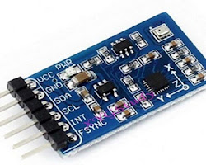Opens in a new window[](https://www.elprocus.com/imu-sensor-working-applications/)www.elprocus.com](https://www.elprocus.com/imu-sensor-working-applications/)

IMU sensor

* **Gyroscopes:** Gyroscopes are used to measure the angular velocity of the rover. They are a popular choice for the robotic arm, as they can be used to track the arm's orientation. Some popular gyroscopes for the URC include the L3GD20H from STMicroelectronics and the MPU-6050 from InvenSense.

[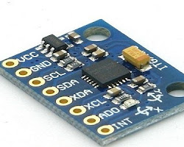Opens in a new window[](https://www.elprocus.com/gyroscope-sensor/)www.elprocus.com](https://www.elprocus.com/gyroscope-sensor/)

Gyroscope sensor

1. **L3GD20H:** The L3GD20H is a popular gyroscope that is used in many different applications. It is a 3-axis gyroscope that measures the angular velocity of the sensor. It is relatively inexpensive and it is easy to use.
2. **ITG-3200:** The ITG-3200 is another popular gyroscope that is used in the URC. It is a 3-axis gyroscope that measures the angular velocity of the sensor. It is more expensive than the L3GD20H, but it offers better performance.
3. **ADIS16448:** The ADIS16448 also has a gyroscope, which is part of its 10-axis sensor suite.

* **Accelerometers:** Accelerometers are used to measure the linear acceleration of the rover. They are a popular choice for the obstacle avoidance mission, as they can be used to detect obstacles in the rover's path. Some popular accelerometers for the URC include the ADXL345 from Analog Devices and the LSM303DLHC from STMicroelectronics.

[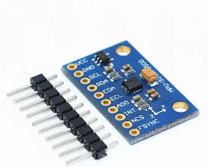Opens in a new window[](https://m.indiamart.com/proddetail/accelerometer-sensor-8533620288.html)m.indiamart.com](https://m.indiamart.com/proddetail/accelerometer-sensor-8533620288.html)

Accelerometer sensor

1. **ADXL345:** The ADXL345 is a popular accelerometer that is used in many different applications. It is a 3-axis accelerometer that measures the acceleration of the sensor. It is relatively inexpensive and it is easy to use.
2. **MPU-6050:** The MPU-6050 also has an accelerometer, as part of its 6-axis sensor suite.
3. **LSM9DS1:** The LSM9DS1 also has an accelerometer, as part of its 9-axis sensor suite.

Here are some of the popular choices of IMU sensors for various tasks of the University Rover Challenge (URC):

* **For navigation:** The most popular choice for navigation is the **AHRS (Attitude and Heading Reference System)**. The AHRS combines the measurements from a gyroscope, accelerometer, and magnetometer to estimate the orientation and angular velocity of the rover.

[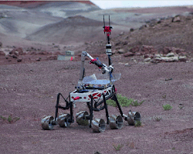Opens in a new window[](https://link.springer.com/chapter/10.1007/978-3-319-91590-6_10)link.springer.com](https://link.springer.com/chapter/10.1007/978-3-319-91590-6_10)

AHRS (Attitude and Heading Reference System) for the University Rover Challenge (URC)

* **For robotic arm control:** The most popular choice for robotic arm control is the **IMU (Inertial Measurement Unit)**. The IMU combines the measurements from a gyroscope and accelerometer to estimate the orientation and angular velocity of the robotic arm.

[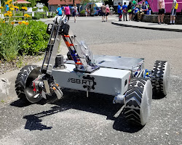Opens in a new window[](https://sbroboticsteam.com/rover.html)sbroboticsteam.com](https://sbroboticsteam.com/rover.html)

IMU (Inertial Measurement Unit) for the University Rover Challenge (URC)

* **For science experiments:** The most popular choice for science experiments is the **MEMS (Micro Electro Mechanical Systems) IMU**. The MEMS IMU is a small and lightweight IMU that is ideal for experiments that require portability.

[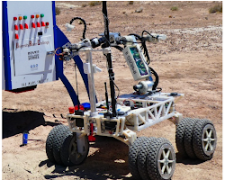Opens in a new window[](https://www.mdpi.com/2076-3417/13/1/439?type=check_update&version=2)www.mdpi.com](https://www.mdpi.com/2076-3417/13/1/439?type=check_update&version=2)

MEMS (Micro Electro Mechanical Systems) IMU

Here are some of the popular choices of GPS for various tasks of the University Rover Challenge (URC):

* **Global Navigation Satellite System (GNSS):** GNSS is the most popular choice for GPS in the URC. It is a constellation of satellites that provides global positioning and timing information. The most common GNSS is the Global Positioning System (GPS), but there are also other GNSS systems such as the Russian GLONASS, the European Galileo, and the Chinese BeiDou. GNSS receivers are the most common type of GPS receiver. They use signals from multiple satellites to determine the location of the rover. GNSS receivers are relatively inexpensive and easy to use. However, they can be affected by interference from buildings, trees, and other objects.

[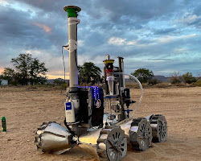Opens in a new window[](https://ou.edu/soonerrover/about.html)ou.edu](https://ou.edu/soonerrover/about.html)

Global Navigation Satellite System (GNSS) for the University Rover Challenge (URC)

* **Inertial Navigation System (INS):** INS is a navigation system that uses inertial sensors to measure the orientation and angular velocity of the rover. It does not require external signals, such as GPS, to operate. However, INS can drift over time, so it is often used in conjunction with GNSS to improve accuracy.

[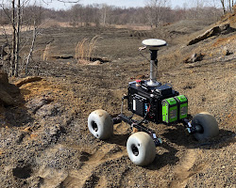Opens in a new window[](https://wvutoday.wvu.edu/stories/2022/08/10/wvu-space-robotics-research-helps-mars-rovers-find-their-footing)wvutoday.wvu.edu](https://wvutoday.wvu.edu/stories/2022/08/10/wvu-space-robotics-research-helps-mars-rovers-find-their-footing)

Inertial Navigation System (INS) for the University Rover Challenge (URC)

* **Visual Odometry:** Visual odometry is a navigation technique that uses cameras to track the movement of the rover. It does not require external signals, such as GPS, to operate. However, visual odometry is susceptible to errors due to changes in lighting and terrain.

[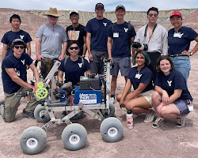Opens in a new window[](https://jacobsschool.ucsd.edu/news/release/3472)jacobsschool.ucsd.edu](https://jacobsschool.ucsd.edu/news/release/3472)

Visual Odometry for the University Rover Challenge (URC)

• **Dead reckoning:** Dead reckoning is a navigation technique that uses the previous position and velocity of a vehicle to estimate its current position. Dead reckoning is not as accurate as GNSS or INS, but it is a simple and reliable technique that can be used in areas with no GPS reception.

[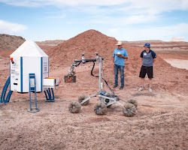Opens in a new window[](https://www.kuer.org/health-science-environment/2023-06-15/byu-mars-university-rover-challenge-utah-desert)www.kuer.org](https://www.kuer.org/health-science-environment/2023-06-15/byu-mars-university-rover-challenge-utah-desert)

Dead reckoning for the University Rover Challenge (URC)

Here are some of the other popular choices of range sensors for various tasks of the University Rover Challenge (URC):

* **Time of flight (ToF) sensors:** ToF sensors measure the time it takes for a light pulse to travel from the sensor to an object and back. They are a popular choice for obstacle avoidance and navigation because they are relatively inexpensive and easy to use. However, they can be affected by dust and other particles in the air.

[Opens in a new window[](https://www.kuer.org/health-science-environment/2023-06-15/byu-mars-university-rover-challenge-utah-desert)www.kuer.org](https://www.kuer.org/health-science-environment/2023-06-15/byu-mars-university-rover-challenge-utah-desert)

Time of flight (ToF) sensors for the University Rover Challenge (URC)

Communication

Here are the steps involved in building a communication system between the rover and ground station:

1. **Choose the right communication protocol:** The communication protocol is the set of rules that govern how the data is transmitted between the rover and the ground station. There are a number of different communication protocols available, each with its own advantages and disadvantages. The team should choose a protocol that is appropriate for the specific needs of their rover.
2. **Select the appropriate hardware:** The hardware for the communication system will depend on the communication protocol that is chosen. The team will need to select a radio modem, an antenna, and other necessary components.
3. **Design the communication system:** The team needs to design the communication system to meet the specific requirements of their rover. This includes factors such as the range, the data rate, and the power consumption.
4. **Implement the communication system:** The team needs to implement the communication system on the rover and the ground station. This includes programming the radio modems and configuring the other components.
5. **Test the communication system:** The team needs to test the communication system to ensure that it is working properly. This includes testing the range, the data rate, and the power consumption.

Here are some additional considerations for building a communication system between the rover and ground station:

* The range: The range of the communication system is the distance between the rover and the ground station that the system can reliably transmit data. The range will depend on the power of the radio modems and the antenna.
* The data rate: The data rate is the speed at which data can be transmitted between the rover and the ground station. The data rate will depend on the bandwidth of the communication channel and the coding scheme that is used.
* The power consumption: The power consumption of the communication system is an important factor, as the rover needs to be able to operate for a long time. The power consumption will depend on the power of the radio modems and the antenna.
* The reliability: The communication system must be reliable, as the rover cannot operate without it. The reliability of the system will depend on the quality of the hardware and software.
* The distance: The distance between the rover and the ground station will determine the type of communication technology that you need to use. For example, radio is a good choice for short-range communication, while optical or laser is a good choice for long-range communication.
* The environment: The environment that the rover is operating in will also affect the choice of communication technology. For example, radio waves can be blocked by obstacles, so you may need to use a different technology in a dusty or rocky environment.
* The budget: The budget will also affect the choice of communication technology. Radio is the most affordable option, while optical and laser are more expensive.

Here are some good and popular design choices for the communication system between rover and ground station in the University Rover Challenge (URC):

* **Use a directional antenna:** A directional antenna will help to improve the range and reliability of the communication system. The antenna should be pointed in the direction of the ground station.

[Opens in a new window[](https://jacobsschool.ucsd.edu/news/release/3472)jacobsschool.ucsd.edu](https://jacobsschool.ucsd.edu/news/release/3472)

Directional antenna for the University Rover Challenge (URC)

* **Use a high-gain antenna:** A high-gain antenna will also help to improve the range and reliability of the communication system. The antenna will need to be mounted high up on the rover to get a good view of the ground station.

[Opens in a new window[](https://jacobsschool.ucsd.edu/news/release/3472)jacobsschool.ucsd.edu](https://jacobsschool.ucsd.edu/news/release/3472)

High-gain antenna for the University Rover Challenge (URC)

* **Use a redundant communication system:** A redundant communication system will help to ensure that the rover can always communicate with the ground station. The team should have at least two different communication systems, such as Wi-Fi and LoRaWAN.
* **Use a fail-safe communication system:** A fail-safe communication system will help to ensure that the rover can always communicate with the ground station, even if the primary communication system fails. The fail-safe communication system could be a wired connection between the rover and the ground station.
* **Use a robust communication protocol:** The communication protocol should be robust and reliable. The protocol should be able to handle interference and other challenges that may be encountered on Mars.
* **Use a low-power radio modem:** A low-power radio modem will reduce the power consumption of the communication system, which will allow the rover to operate for longer periods of time.
* **Use a reliable communication protocol:** The communication protocol should be reliable and should be able to transmit data over long distances. Some good choices for the URC include Zigbee, LoRaWAN, and 4G LTE.
* **Use a high-quality radio modem:** The radio modem should be of high quality and should be able to transmit data at a high speed. The team should choose a radio modem that is specifically designed for the communication protocol that they are using.
* **Use error-correcting codes:** Error-correcting codes can help to improve the reliability of the communication system by detecting and correcting errors in the data that is transmitted. The team should choose an error-correcting code that is appropriate for the communication protocol that they are using.
* **Test the communication system thoroughly:** The communication system should be tested thoroughly to ensure that it is working properly. The team should test the range, the data rate, and the reliability of the system.

Here are some good and popular choices of communication protocols for the communication system between rover and ground station in the University Rover Challenge (URC):

* **Wi-Fi:** Wi-Fi is a popular choice for short-range communication between the rover and the ground station. It is relatively inexpensive and easy to set up. It is a wireless communication protocol that is used for high-speed data transmission. Wi-Fi has a range of up to 100 meters, and it can support data rates of up to 1 Gbps. However, Wi-Fi is not suitable for long-range communication, as the signal can be easily blocked by obstacles.

[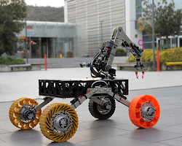Opens in a new window[](https://www.ozyegin.edu.tr/en/announcements/11658/ozu-rover-team-advances-to-the-finals-in-the-university-rover-challenge!)www.ozyegin.edu.tr](https://www.ozyegin.edu.tr/en/announcements/11658/ozu-rover-team-advances-to-the-finals-in-the-university-rover-challenge!)

Wi-Fi for the University Rover Challenge (URC)

* **Bluetooth:** Bluetooth is another popular choice for short-range communication between the rover and the ground station. It is a wireless communication protocol that is used for low-power data transmission. Bluetooth has a range of up to 10 meters, and it can support data rates of up to 2 Mbps. However, Bluetooth is not suitable for long-range communication, as the signal can be easily blocked by obstacles.

[Opens in a new window[](https://engineering.usu.edu/mae/students/senior-projects/fall2018-spring2019/university-rover-competition)engine](https://engineering.usu.edu/mae/students/senior-projects/fall2018-spring2019/university-rover-competition)



* **Zigbee** is a wireless communication protocol that is used for low-power, low-data-rate applications. Zigbee has a range of up to 100 meters, and it can support data rates of up to 250 kbps. Zigbee is often used for sensor networks, as it is very energy efficient. Zigbee is a low-power wireless communication protocol that is well-suited for long-range communication between the rover and the ground station. It is not as fast as Wi-Fi or Bluetooth, but it is more reliable and it can operate in harsh environments.

[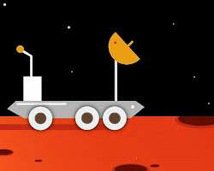Opens in a new window[](https://www.ketto.org/fundraiser/teamaresnsit)www.ketto.org](https://www.ketto.org/fundraiser/teamaresnsit)

Zigbee for the University Rover Challenge (URC)

* **LoRaWAN:** LoRaWAN is a low-power wide-area network (LPWAN) technology that is well-suited for long-range communication between the rover and the ground station. It is even more power-efficient than Zigbee and it can operate in even more harsh environments. LoRaWAN is a low-power, wide-area network (LPWAN) protocol that is used for long-range communication. LoRaWAN has a range of up to 10 kilometers, and it can support data rates of up to 50 kbps. LoRaWAN is often used for IoT applications, as it is very energy efficient and can operate in harsh environments.

[Opens in a new window[](https://en.wikipedia.org/wiki/University_Rover_Challenge)en.wikipedia.org](https://en.wikipedia.org/wiki/University_Rover_Challenge)

LoRaWAN for the University Rover Challenge (URC)

* **4G/5G:** 4G and 5G cellular networks are a good choice for long-range communication between the rover and the ground station. They offer high data rates and long ranges, but they require more power than other options. Is used for high-speed data transmission. 4G/LTE has a range of up to 10 kilometers, and it can support data rates of up to 1 Gbps.

[Opens in a new window[](https://www.thedailystar.net/tech-startup/news/uiu-places-1st-among-asian-teams-university-rover-challenge-2023-3340006)www.thedailystar.net](https://www.thedailystar.net/tech-startup/news/uiu-places-1st-among-asian-teams-university-rover-challenge-2023-3340006)

4G/5G for the University Rover Challenge (URC)

Here are some good and popular choices of hardware for the communication system between rover and ground station in the University Rover Challenge (URC):

* **Radio modem:** The radio modem is the device that converts the digital data from the rover or ground station into a signal that can be transmitted over the radio waves. There are a number of different radio modems available, each with its own advantages and disadvantages. The team should choose a radio modem that is appropriate for the specific needs of their rover.

[Opens in a new window[](https://en.wikipedia.org/wiki/University_Rover_Challenge)en.wikipedia.org](https://en.wikipedia.org/wiki/University_Rover_Challenge)

Radio modem for the University Rover Challenge (URC)

* **Antenna:** The antenna is the device that radiates the radio waves from the rover or ground station and receives the radio waves from the other device. The antenna must be designed to match the frequency of the radio modem and it must be positioned in a way that it can receive and transmit signals effectively.

[Opens in a new window[](https://engineering.usu.edu/mae/students/senior-projects/fall2018-spring2019/university-rover-competition)engineering.usu.edu](https://engineering.usu.edu/mae/students/senior-projects/fall2018-spring2019/university-rover-competition)

Antenna for the University Rover Challenge (URC)

* **Power supply:** The power supply provides the power to the radio modem and the antenna. The power supply must be able to provide enough power for the radio modem and the antenna to operate properly.

[Opens in a new window[](https://en.wikipedia.org/wiki/University_Rover_Challenge)en.wikipedia.org](https://en.wikipedia.org/wiki/University_Rover_Challenge)

Power supply for the University Rover Challenge (URC)

* **Interface board:** The interface board is the device that connects the radio modem to the other components of the rover or ground station. The interface board must be compatible with the radio modem and the other components.

[Opens in a new window[](https://en.wikipedia.org/wiki/University_Rover_Challenge)en.wikipedia.org](https://en.wikipedia.org/wiki/University_Rover_Challenge)

Interface board for the University Rover Challeng

• **Power supplies:** The power supplies are used to power the radio modems and the antennas. The power supply must be able to provide enough power to the devices while also being lightweight and efficient.

[Opens in a new window[](https://en.wikipedia.org/wiki/University_Rover_Challenge)en.wikipedia.org](https://en.wikipedia.org/wiki/University_Rover_Challenge)

Power supplies for the University Rover Challenge (URC)

• **Interfaces:** The interfaces are used to connect the radio modems, the antennas, and the power supplies to the rover's computer. The type of interface that is used will depend on the computer that is used.

[Opens in a new window[](https://engineering.usu.edu/mae/students/senior-projects/fall2018-spring2019/university-rover-manipulation)engineering.usu.edu](https://engineering.usu.edu/mae/students/senior-projects/fall2018-spring2019/university-rover-manipulation)

Interfaces for the University Rover Challenge (U

• **Data cables:** The data cables are used to connect the radio modems and the antennas. The team will need to select data cables that are compatible with the radio modems and that are long enough to reach the desired location of the antennas.

[Opens in a new window[](https://en.wikipedia.org/wiki/University_Rover_Challenge)en.wikipedia.org](https://en.wikipedia.org/wiki/University_Rover_Challenge)

Data cables for the University Rover Challenge (URC)

• **Other components:** The team may need to select other components for the communication system, such as filters, amplifiers, and multiplexers. The specific components that are needed will depend on the chosen communication protocol and the desired range and data rate. Few other components are a router, a switch, or a firewall. The specific components that are needed will depend on the specific needs of the team.

Here are some good and popular designs for the communication system between rover and ground station in the University Rover Challenge (URC):

* **Direct line-of-sight communication:** This is the simplest and most reliable communication system. It uses a directional antenna to transmit data directly between the rover and the ground station. The range of this system will depend on the power of the radio modems and the antenna.

[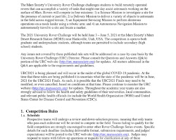Opens in a new window[](https://www.scribd.com/document/490913404/University-Rover-Challenge-Rules-2021)www.scribd.com](https://www.scribd.com/document/490913404/University-Rover-Challenge-Rules-2021)

Direct line-of-sight communication for the University Rover Challenge (URC)

* **Spread spectrum communication:** This is a more complex communication system that uses a wider bandwidth than direct line-of-sight communication. This makes it more resistant to interference and it can operate over longer distances.

[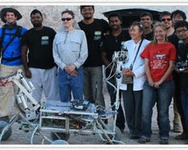Opens in a new window[](https://www.srmist.edu.in/srm-institute-of-science-and-technology-students-emerged-as-asian-continental-champions-in-university-rover-challenge-14/)www.srmist.edu.in](https://www.srmist.edu.in/srm-institute-of-science-and-technology-students-emerged-as-asian-continental-champions-in-university-rover-challenge-14/)

Spread spectrum communication for the University Rover Challenge (URC)

* **Repeater communication:** This system uses a repeater to extend the range of the communication system. The repeater is placed in a location that can see both the rover and the ground station. The repeater then amplifies the signal and retransmits it to the ground station.

[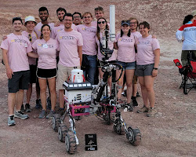Opens in a new window[](https://ece.engin.umich.edu/stories/mrover-crowned-champions-of-the-university-rover-challenge)ece.engin.umich.edu](https://ece.engin.umich.edu/stories/mrover-crowned-champions-of-the-university-rover-challenge)

Repeater communication for the University Rover Challenge (URC)

* **Mesh networking:** This is a more complex communication system that allows the rover to communicate with other devices, such as other rovers or the ground station. This can be useful in situations where the rover is not in direct line-of-sight with the ground station.

[Opens in a new window[](https://www.thedailystar.net/tech-startup/news/uiu-places-1st-among-asian-teams-university-rover-challenge-2023-3340006)www.thedailystar.net](https://www.thedailystar.net/tech-startup/news/uiu-places-1st-among-asian-teams-university-rover-challenge-2023-3340006)

Mesh networking for the University Rover Challenge (URC)

* **Satellite communication:** This design uses satellites to communicate between the rover and the ground station. This design has the longest range, but it is also the most expensive and complex.

[Opens in a new window[](https://en.wikipedia.org/wiki/University_Rover_Challenge)en.wikipedia.org](https://en.wikipedia.org/wiki/University_Rover_Challenge)

Satellite communication for the University Ro

* **Centralized communication:** In this design, the rover communicates with a central hub, which then communicates with the ground station. This design is more complex than direct communication or mesh networking, but it can be more reliable, as the central hub can act as a failsafe in case of a problem with the rover or the ground station.

[Opens in a new window[](https://ece.engin.umich.edu/stories/mrover-crowned-champions-of-the-university-rover-challenge)ece.engin.umich.edu](https://ece.engin.umich.edu/stories/mrover-crowned-champions-of-the-university-rover-challenge)

Centralized communication for the University

There are a few different ways to implement and program a communication system between the rover and ground station in the University Rover Challenge (URC). Here are two possible ways:

**Way 1:**

1. The team can use a pre-made communication system. There are a number of commercial communication systems available that can be used for the URC. These systems typically include the radio modems, antennas, and software needed to implement the communication system.

[Opens in a new window[](https://en.wikipedia.org/wiki/University_Rover_Challenge)en.wikipedia.org](https://en.wikipedia.org/wiki/University_Rover_Challenge)

Pre-made communication system for the University Rover Challenge (URC)

1. The team can design and implement their own communication system. This can be a more challenging option, but it allows the team to have more control over the system. The team would need to select the radio modems, antennas, and other components, and then design and implement the software.

**Way 2:**

1. The team can use a cloud-based communication system. There are a number of cloud-based communication systems available that can be used for the URC. These systems typically provide a platform for the team to develop and deploy their own communication software.

[Opens in a new window[](https://www.environmentalbiophysics.org/university-rover-challenge/)www.environmentalbiophysics.org](https://www.environmentalbiophysics.org/university-rover-challenge/)

Cloud-based communication system for the University Rover Challenge (URC)

1. The team can use a combination of pre-made and custom components. This can be a good option if the team wants to use some pre-made components but also wants to have some control over the system. The team would need to select the pre-made components and then design and implement the custom components.

No matter which way the team chooses to implement and program the communication system, it is important to ensure that the system is reliable and secure. The system must be able to operate reliably in the harsh Martian environment, and it must be secure from cyberattacks.

Here are some additional considerations for implementing and programming a communication system for the URC:

* The communication system must be able to operate in the harsh Martian environment. The system must be able to withstand the extreme temperatures, dust, and radiation of Mars.
* The communication system must be secure from cyberattacks. The system must be able to protect itself from unauthorized access and malicious attacks.
* The communication system must be easy to use and maintain. The system must be easy for the team to operate and maintain, even in the challenging conditions of the Martian environment.

the ways of implementing and programming a communication system between rover and ground station in the University Rover Challenge (URC):

* **Software-defined radio (SDR):** SDR is a radio communication system that uses software to control the radio hardware. This allows the team to customize the communication system to meet their specific needs.

[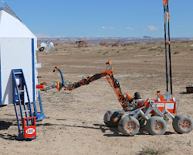Opens in a new window[](https://www.marssociety.org/news/2022/05/21/relativity-space-becomes-urc-sponsor/)www.marssociety.org](https://www.marssociety.org/news/2022/05/21/relativity-space-becomes-urc-sponsor/)

Software-defined radio (SDR) for the University Rover Challenge (URC)

* **Commercial off-the-shelf (COTS) radio:** COTS radios are pre-made radios that can be purchased from a vendor. This is a quick and easy way to get a communication system up and running. However, it may not be as customizable as an SDR.

[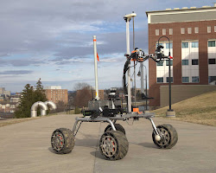Opens in a new window[](https://media.statler.wvu.edu/news/2022/04/06/west-virginia-university-robotics-team-advances-to-final-round-in-university-rover-challenge)media.statler.wvu.edu](https://media.statler.wvu.edu/news/2022/04/06/west-virginia-university-robotics-team-advances-to-final-round-in-university-rover-challenge)

Commercial off-the-shelf (COTS) radio for the University Rover Challenge (URC)

* **Combination of SDR and COTS:** The team can also use a combination of SDR and COTS radios. This can give them the best of both worlds, with the flexibility of SDR and the convenience of COTS radios.
* **Open-source software:** There are a number of open-source software packages available for implementing a communication system. These packages can be used to simplify the development process and to reduce the cost of the system.

Here are some ways of testing a communication system between rover and ground station in the University Rover Challenge (URC):

* **Range testing:** Range testing is used to determine the maximum distance between the rover and the ground station that the communication system can reliably transmit data. This can be done by placing the rover and the ground station at increasing distances apart and transmitting data between them.
* **Data rate testing:** Data rate testing is used to determine the maximum data rate that the communication system can achieve. This can be done by transmitting data between the rover and the ground station at different data rates.
* **Power consumption testing:** Power consumption testing is used to determine the power consumption of the communication system. This can be done by measuring the power consumption of the radio modems and the antenna.
* **Reliability testing:** Reliability testing is used to determine the reliability of the communication system. This can be done by transmitting data between the rover and the ground station repeatedly and measuring the number of errors that occur.
* **Environmental testing:** Environmental testing is used to determine how the communication system performs in different environmental conditions. This can be done by testing the system in different temperatures, humidity, and other environmental conditions.
* **Signal strength testing:** Signal strength testing is used to determine the strength of the signal between the rover and the ground station. This can be done by using a signal strength meter to measure the signal strength at different distances between the rover and the ground station.
* **Interference testing:** Interference testing is used to determine how susceptible the communication system is to interference. This can be done by transmitting data between the rover and the ground station in the presence of different sources of interference.